### **1 Completed Sales Orders (Physical Items)**

Business Problem:  
Merchants need to track only physical items (requiring shipping and fulfillment) for logistics and shipping-cost analysis.

Fields to Retrieve:

* ORDER_ID
* ORDER_ITEM_SEQ_ID
* PRODUCT_ID
* PRODUCT_TYPE_ID
* SALES_CHANNEL_ENUM_ID
* ORDER_DATE
* ENTRY_DATE
* STATUS_ID
* STATUS_DATETIME
* ORDER_TYPE_ID
* PRODUCT_STORE_ID

select distinct oh.ORDER_ID, oi.ORDER_ITEM_SEQ_ID, oi.PRODUCT_ID, p.PRODUCT_TYPE_ID,

oh.SALES_CHANNEL_ENUM_ID, oh.ORDER_DATE, oh.ENTRY_DATE,

oh.STATUS_ID, os.STATUS_DATETIME, oh.ORDER_TYPE_ID, oh.PRODUCT_STORE_ID

from order_header oh

join order_item oi on oi.ORDER_ID=oh.ORDER_ID

join order_status os on os.ORDER_ID=oh.ORDER_ID

join product p on p.product_id=oi.product_id

join product_type pt on pt.PRODUCT_TYPE_ID=p.PRODUCT_TYPE_ID

where pt.IS_PHYSICAL='Y'

and oh.STATUS_ID = 'ORDER_COMPLETED';

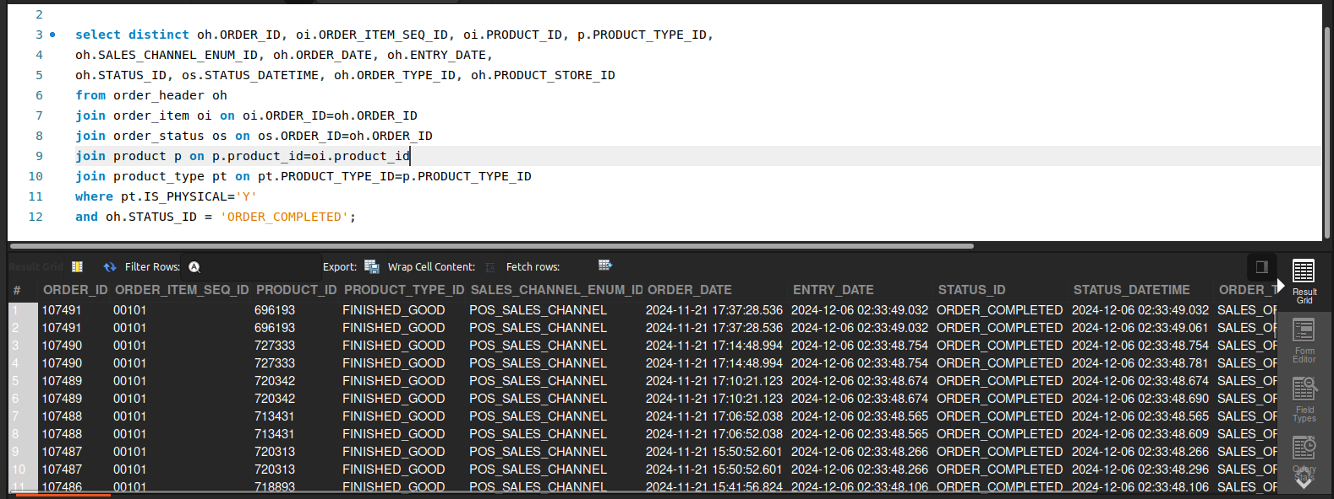

### **2 Completed Return Items**

Business Problem:  
Customer service and finance often need insights into returned items to manage refunds, replacements, and inventory restocking.

Fields to Retrieve:

* RETURN_ID
* ORDER_ID
* PRODUCT_STORE_ID
* STATUS_DATETIME
* ORDER_NAME
* FROM_PARTY_ID
* RETURN_DATE
* ENTRY_DATE
* RETURN_CHANNEL_ENUM_ID

select ri.RETURN_ID, ri.order_id, oh.PRODUCT_STORE_ID, rs.STATUS_DATETIME,

oh.ORDER_NAME, rh.FROM_PARTY_ID, rh.ENTRY_DATE, rh.RETURN_DATE ,rh.RETURN_CHANNEL_ENUM_ID

from return_item ri

join order_header oh on oh.order_id=ri.ORDER_ID and ri.STATUS_ID='RETURN_COMPLETED'

join return_header rh on rh.RETURN_ID=ri.RETURN_ID

join return_status rs on rs.return_id=ri.RETURN_ID and rs.STATUS_ID='RETURN_COMPLETED';￼

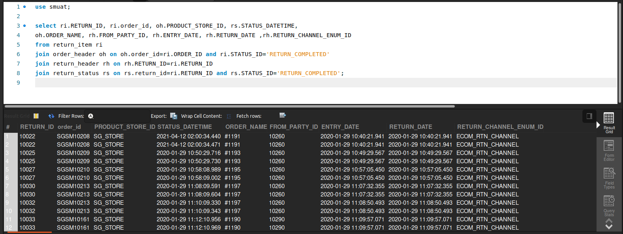

### **3 Single-Return Orders (Last Month)**

Business Problem:  
The mechandising team needs a list of orders that only have one return.

Fields to Retrieve:

* PARTY_ID
* FIRST_NAME

select rh.FROM_PARTY_ID as PARTY_ID, p.FIRST_NAME

from return_header rh

join person p on p.party_id=rh.FROM_PARTY_ID

where rh.RETURN_DATE>=date_format(Now() - Interval 1 month,'%24-%m-01') and

rh.RETURN_DATE< date_format(Now(), '%24-%m-01')

group by rh.FROM_PARTY_ID, p.FIRST_NAME

having count(rh.RETURN_ID)=1;

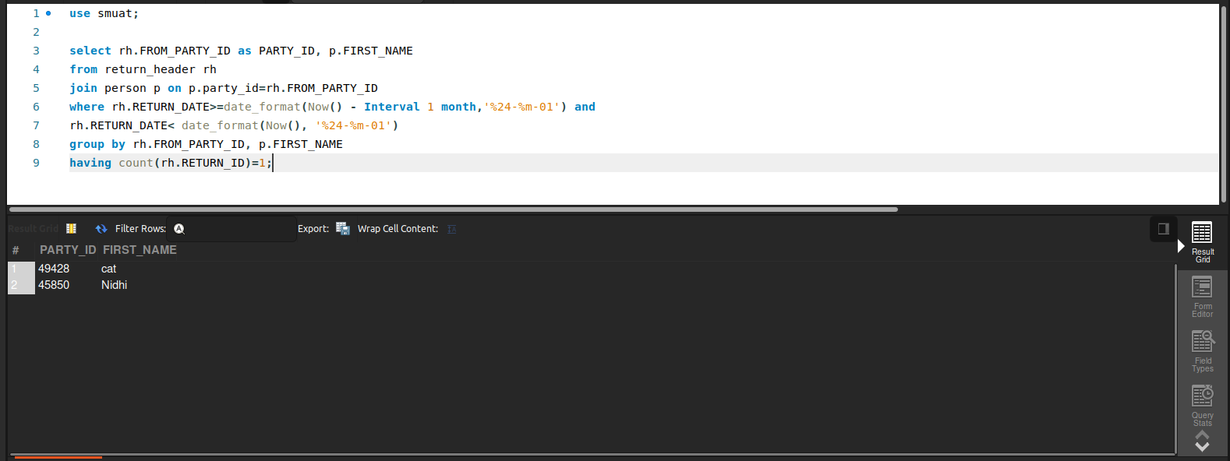

### **4 Returns and Appeasements**

Business Problem:  
The retailer needs the total amount of items, were returned as well as how many appeasements were issued.

Fields to Retrieve:

* TOTAL RETURNS
* RETURN $ TOTAL
* TOTAL APPEASEMENTS
* APPEASEMENTS $ TOTAL

select count(rh.RETURN_ID) as TOTAL_RETURNS, sum(ri.RETURN_PRICE * ri.RETURN_QUANTITY) as RETURN_$_TOTAL,

count(rd.RETURN_ID) as TOTAL_APPEASEMENTS, sum(rd.AMOUNT) as APPEASEMENTS_TOTAL

from return_header rh

join return_item ri on rh.RETURN_ID=ri.RETURN_ID

join return_adjustment rd on rh.RETURN_ID=rd.RETURN_ID

and rd.RETURN_ADJUSTMENT_TYPE_ID='appeasement';

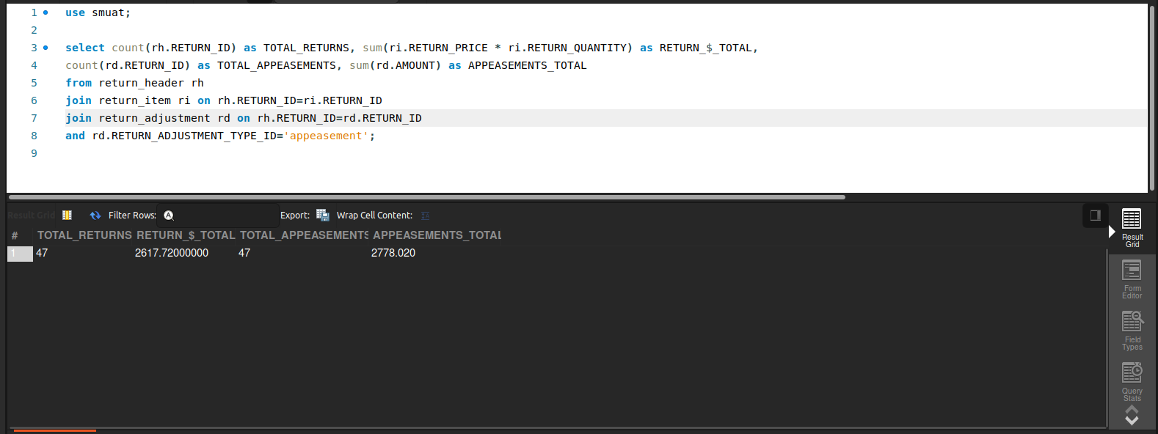

### **5 Detailed Return Information**

Business Problem:  
Certain teams need granular return data (reason, date, refund amount) for analyzing return rates, identifying recurring issues, or updating policies.

Fields to Retrieve:

* RETURN_ID
* ENTRY_DATE
* RETURN_ADJUSTMENT_TYPE_ID (refund type, store credit, etc.)
* AMOUNT
* COMMENTS
* ORDER_ID
* ORDER_DATE
* RETURN_DATE
* PRODUCT_STORE_ID

select rh.return_id, rh.ENTRY_DATE, ra.return_adjustment_type_id,

ra.amount, ra.comments, ri.order_id, oh.order_date, rh.return_date, oh.product_store_id

from return_header rh

join return_item ri on ri.RETURN_ID=rh.RETURN_ID

join return_adjustment ra on ra.RETURN_ID=rh.RETURN_ID

join order_header oh on ri.order_id=oh.ORDER_ID;

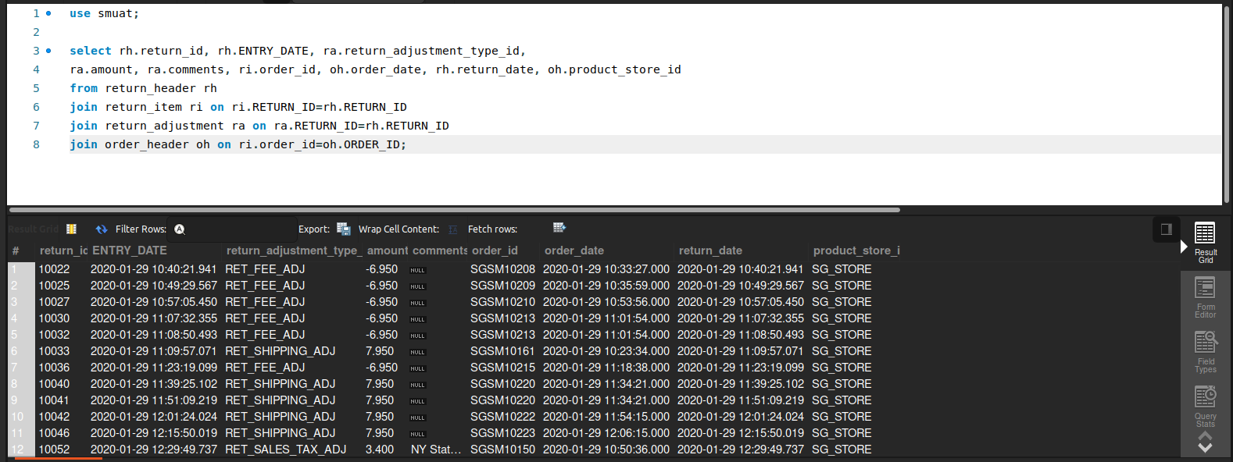

### **6 Orders with Multiple Returns**

Business Problem:  
Analyzing orders with multiple returns can identify potential fraud, chronic issues with certain items, or inconsistent shipping processes.

Fields to Retrieve:

* ORDER_ID
* RETURN_ID
* RETURN_DATE
* RETURN_REASON
* RETURN_QUANTITY

select ri.ORDER_ID, ri.RETURN_ID, rh.RETURN_DATE, rs.DESCRIPTION as RETURN_REASON,

ri.RETURN_QUANTITY

from return_header rh

join return_item ri on rh.RETURN_ID = ri.RETURN_ID

join return_reason rs on ri.RETURN_REASON_ID = rs.RETURN_REASON_ID

where ri.ORDER_ID IN (

select ORDER_ID from return_item group by ORDER_ID having count(RETURN_ID) > 1

)

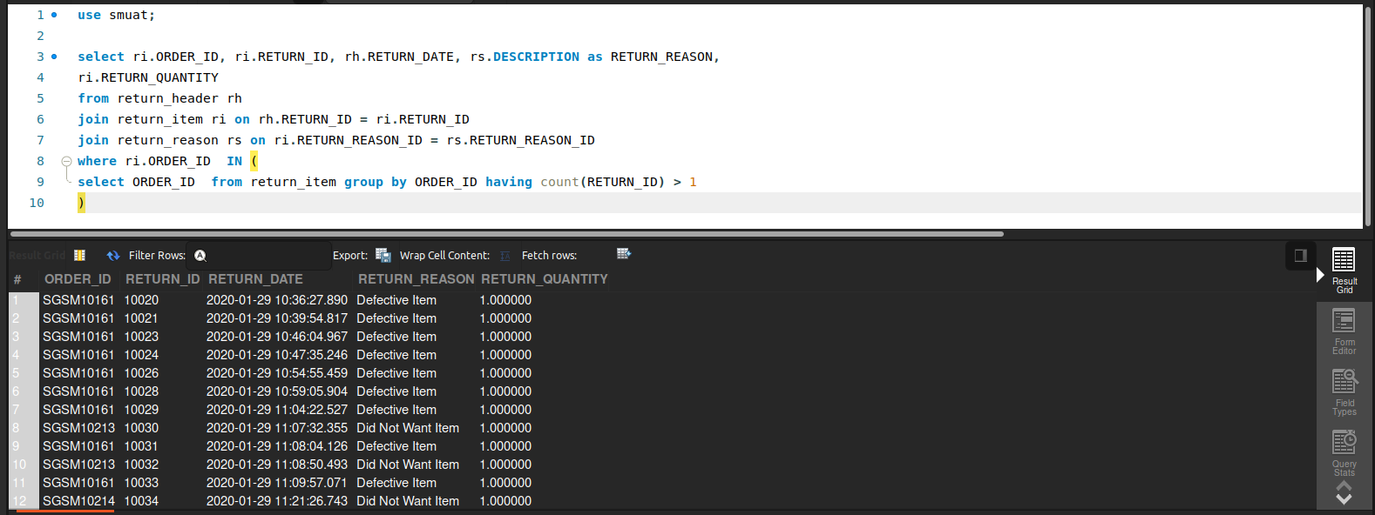

### **7 Store with Most One-Day Shipped Orders (Last Month)**

Business Problem:  
Identify which facility (store) handled the highest volume of “one-day shipping” orders in the previous month, useful for operational benchmarking.

Fields to Retrieve:

* FACILITY_ID
* FACILITY_NAME
* TOTAL_ONE_DAY_SHIP_ORDERS
* REPORTING_PERIOD

select f.facility_id, f.facility_name,

count(oi.order_id) as TOTAL_ONE_DAY_SHIP_ORDERS

from facility f

join order_item_ship_group oi on f.FACILITY_ID = oi.FACILITY_ID AND oi.SHIPMENT_METHOD_TYPE_ID = 'NEXT_DAY'

join order_header oh on oh.ORDER_ID = oi.ORDER_ID

where oh.ORDER_DATE >= DATE_FORMAT(NOW() - INTERVAL 1 MONTH, '23-%m-01')

AND oh.ORDER_DATE < DATE_FORMAT(NOW(), '23-%m-01')

group by f.FACILITY_ID , f.FACILITY_NAME

order by TOTAL_ONE_DAY_SHIP_ORDERS desc

limit 1;

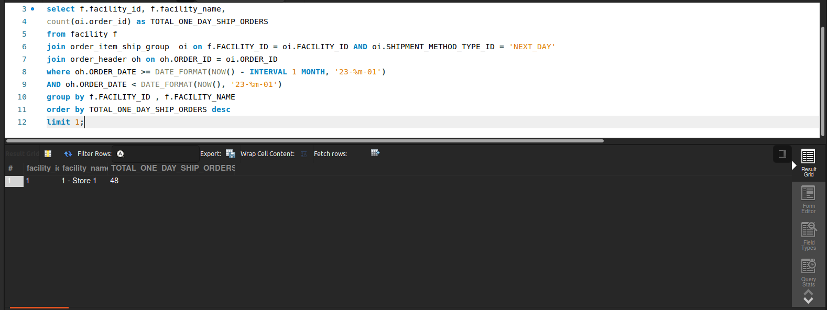

### **8 List of Warehouse Pickers**

Business Problem:  
Warehouse managers need a list of employees responsible for picking and packing orders to manage shifts, productivity, and training needs.

Fields to Retrieve:

* PARTY_ID (or Employee ID)
* NAME (First/Last)
* ROLE_TYPE_ID (e.g., “WAREHOUSE_PICKER”)
* FACILITY_ID (assigned warehouse)
* STATUS (active or inactive employee)

select pr.PARTY_ID, per.FIRST_NAME, pr.ROLE_TYPE_ID, p.FACILITY_ID, prt.STATUS_ID

from picklist p

join picklist_role pr on pr.PICKLIST_ID=p.PICKLIST_ID

join party prt on prt.PARTY_ID=pr.PARTY_ID

join person per on per.PARTY_ID=prt.PARTY_ID

where pr.ROLE_TYPE_ID='WAREHOUSE_PICKER';

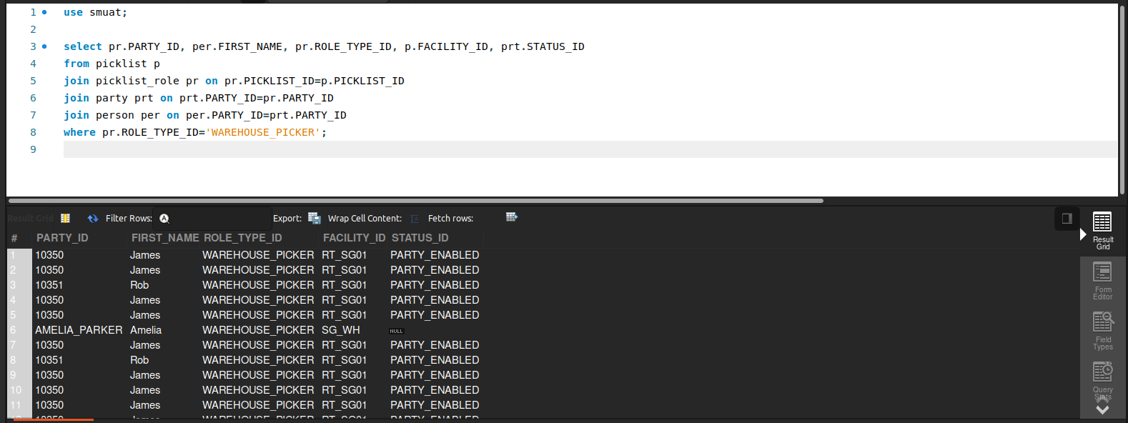

### **9 Total Facilities That Sell the Product**

Business Problem:  
Retailers want to see how many (and which) facilities (stores, warehouses, virtual sites) currently offer a product for sale.

Fields to Retrieve:

* PRODUCT_ID
* PRODUCT_NAME (or INTERNAL_NAME)
* FACILITY_COUNT (number of facilities selling the product)

select ii.product_id, p.INTERNAL_NAME ,count(f.FACILITY_ID) as FACILITY_COUNT

from inventory_item ii

join product p on ii.PRODUCT_ID=p.product_id

join facility f on ii.FACILITY_ID=f.FACILITY_ID

group by ii.PRODUCT_ID;

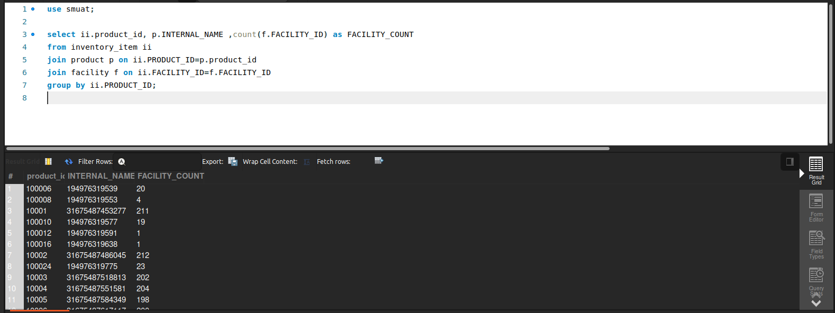

### **10 Total Items in Various Virtual Facilities**

Business Problem:  
Retailers need to study the relation of inventory levels of products to the type of facility it's stored at. Retrieve all inventory levels for products at locations and include the facility type Id. Do not retrieve facilities that are of type Virtual.

Fields to Retrieve:

* PRODUCT_ID
* FACILITY_ID
* FACILITY_TYPE_ID
* QOH (Quantity on Hand)
* ATP (Available to Promise)

select ii.PRODUCT_ID, ii.FACILITY_ID, f.FACILITY_TYPE_ID, ii.QUANTITY_ON_HAND_TOTAL, ii.AVAILABLE_TO_PROMISE_TOTAL

from inventory_item ii

join facility f on f.FACILITY_ID=ii.FACILITY_ID

where f.FACILITY_TYPE_ID != 'VIRTUAL_FACILITY';

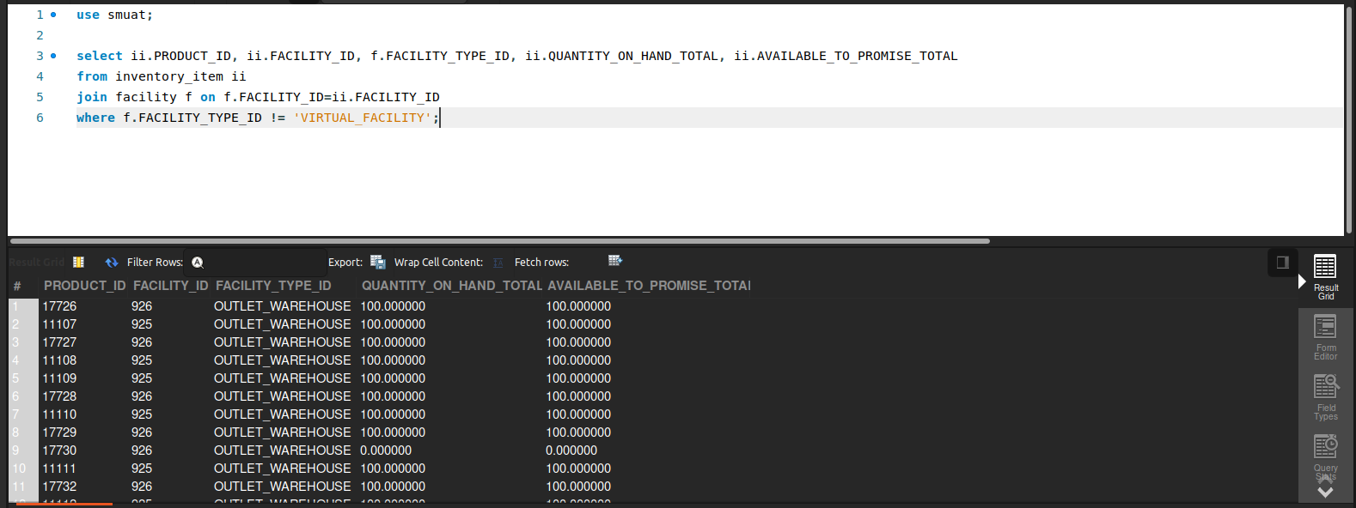

### **11 Transfer Orders Without Inventory Reservation**

Business Problem:  
When transferring stock between facilities, the system should reserve inventory. If it isn’t reserved, the transfer may fail or oversell.

Fields to Retrieve:

* TRANSFER_ORDER_ID
* FROM_FACILITY_ID
* TO_FACILITY_ID
* PRODUCT_ID
* REQUESTED_QUANTITY
* RESERVED_QUANTITY
* TRANSFER_DATE
* STATUS

select it.INVENTORY_TRANSFER_ID as TRANSFER_ORDER_ID, it.PRODUCT_ID,

it.FACILITY_ID as FROM_FACILITY_ID, it.FACILITY_ID_TO as TO_FACILITY_ID,

ois.QUANTITY as REQUESTED_QUANTITY, it.QUANTITY as RESERVED_QUANTITY, it.SEND_DATE as Tranfer_Date, it.STATUS_ID

from inventory_transfer it

join order_item_ship_grp_inv_res ois on it.INVENTORY_ITEM_ID=ois.INVENTORY_ITEM_ID;

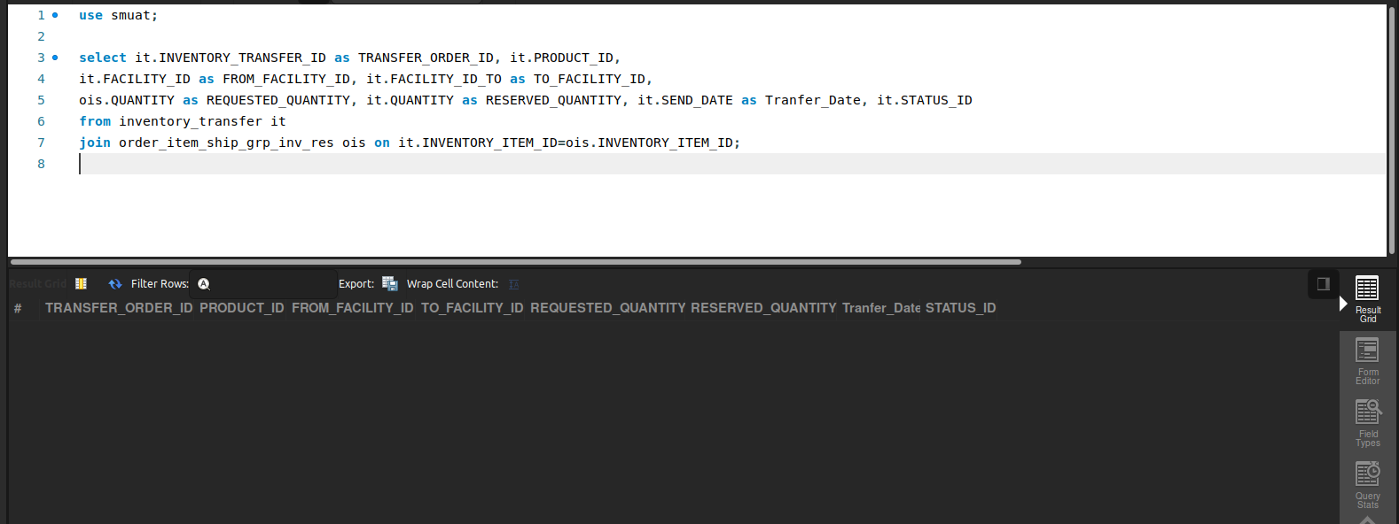

### **12 Orders Without Picklist**

Business Problem:  
A picklist is necessary for warehouse staff to gather items. Orders missing a picklist might be delayed and need attention.

Fields to Retrieve:

* ORDER_ID
* ORDER_DATE
* ORDER_STATUS
* FACILITY_ID
* DURATION (How long has the order been assigned at the facility)

select distinct oh.order_id, oh.order_date, oh.status_id,

ois.facility_id,

datediff(date(os.status_datetime), date(oh.entry_date)) as duration

from order_header oh

join order_item_ship_group ois on ois.ORDER_ID = oh.ORDER_ID

join order_status os on os.ORDER_ID = oh.ORDER_ID

join picklist pl on pl.FACILITY_ID = ois.FACILITY_ID

where pl.STATUS_ID is null;

